Learning Journey
Tic-Tac-Toe Board

Directions: Choose any three activities to complete your Learning Journey. Your selected path should reflect what inspires you, challenges you, or pushes your thinking.
Read Making Numbers Count and discuss how you might implement what you learned. | Create a new data visualization using your institutional data and annotate your choices | Use the Stakeholder Engagement Template to map your own ecosystem of partners.
Disaggregate a dataset you use regularly and identify one concern to address. | Read Effective Data Storytelling. Select one area of focus and develop a data story. | Identify instances where SARA-A surfaced during data discussions throughout the year and consider possible responses.
Read Data Literacy for Educators: Making It Count in Teacher Preparation and Practice and describe how you applied what you learned in your practice. | Have a conversation with a district partner (e.g., principal, mentor teacher) and discuss how they utilize data for continuous improvement. Detail what you learned. | Review the strategies in: Effective Data Visualization and visualize several data points using various strategies.

During our first Community of Practice meeting in the fall, you'll briefly share your Tic-Tac-Toe path and one insight, practice, or commitment you're carrying forward. Our second Community of Practice meeting in the spring will be an opportunity to share your learning journey, what went well, what you would do differently, and how you will continue your data empowerment journey moving forward. Your final reflection will be due at that time.

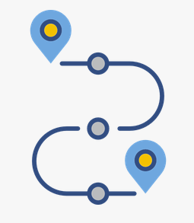 \
Personal Exploratory Learning Journey
From Discovery to Action: Reflecting on Your Data Journey

Reflect on your learning journey to date and respond to the following prompts.
Describe the activities you completed.

What are some key insights and discoveries you made?

How might what you learned apply to the future of education?

What concerns you about unintended consequences based on your learnings?


What did you learn in your explorations that you can give back and share with others?

