Brainstorming Your Data Story

Source: Dykes, B. (2019). Effective data storytelling: How to drive change with data, narrative, and visuals. Hoboken: John Wiley & Sons, Inc.

The Data
What are the data that you want to present? Is the data accurate and reliable?
What do you want to highlight about the data?
What insights do you want the audience to attend to? Are your insights based on the most relevant and appropriate data?
What action do you want the audience to commit to?

The Audience
List the roles (e.g., teacher education faculty, content faculty, district partners, etc.) of the individuals that will comprise your audience. For each role reflect on the following:
- What are their goals and priorities? What do they care about?
- What are their beliefs and preferences? What assumptions might they have about the data you will be presenting? Are they likely to be accepting, resistant, or neutral to the data you are presenting?
- What expectations might they have of the presentation? What questions might they want to see answered?
- What might be the right time to share your story given current responsibilities and demands?
- How familiar are they about the topic you are presenting? Will you need to provide some foundational information prior to telling your data story?
- How data-savvy are they? What considerations do you need to attend to based on their level of data literacy?
- What is the seniority level of your audience? How might that impact how you present your data story (i.e., length, elements, etc.)?
- How diverse is your audience in terms of data literacy, backgrounds, interests, and agendas?
What resistance to your data story may surface and from where (e.g., a particular department) or who (e.g., specific individuals)?

Data Storytelling Arc

Reflect on each of the following and jot down some thoughts/ideas for how you will
move forward in each area.

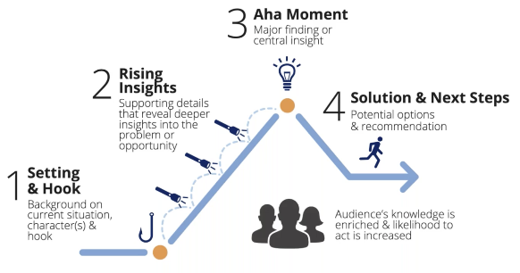
(Dykes, B. 2020)
Setting
- Provide just enough information so audience can understand the data you are sharing.
- Keep it focused and clear.
- Include the hook. This is where the audience gets drawn in, their hmmm moment.
Rising Insights
- Provide additional supporting details so the topic can be explored at a deeper level.
- This is where you are uncovering the problem or opportunity in a direct and focused manner.
Aha Moment
- This is where the major finding or insight becomes evident.
Solution and Next Steps
- This is where you guide your audience to possible solutions, options, and next steps.
Commitment to Action
- Audience commits to act on findings in specific ways (e.g., what will be their first next step to respond to what was learned?).
Evaluating Success
- How will you/the group monitor and evaluate the actions undertaken?

