BranchED
2025 Summer Institute
Case Study At a Crossroad: The Story of Summit Valley College of Education
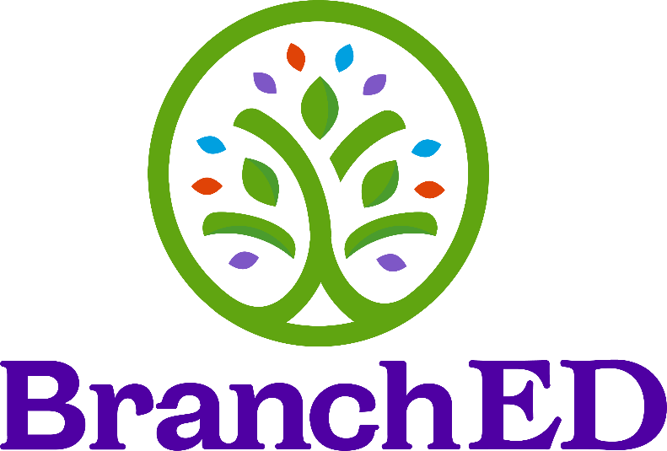
Table of Contents

At a Crossroads: The Story of Summit Valley College of Education 2
Why This Case Matters 2
The College 3
Teacher Candidate Population 3
Challenges 3
Competition from Alternative Certification Providers 3
Enrollment Decline 3
Candidate Performance Concerns 3
The Districts 4
Challenges 4
Reflection 4
Your Charge 5

At a Crossroads: The Story of Summit Valley College of Education

This Case Study is intended to serve as the foundation for a series of data-focused activities. It is not designed to prescribe a solution, but to offer a realistic scenario that invites collaborative inquiry. Through interactive analysis and dialogue, we will explore how a educators might:

- Leverage data to understand complex issues.
- Identify actionable questions for further investigation.
- Engage diverse voices in making meaning of the evidence.

The Case Study addresses the following thematic areas:

- Data Review & Visualization
  - Analyze enrollment, assessment, and transfer trend data. How do these patterns help identify root causes or key questions?
- Program Improvement through Evidence
  - Identify which data might inform curriculum, advising, field placements, or candidate support.
- Stakeholder Engagement
  - Consider how to involve local districts, community colleges, and candidates themselves in interpreting and responding to data findings.

Why This Case Matters

Summit Valley College of Education is at a crossroads, confronting rising competition, falling candidate numbers, and new questions about effectiveness. Its leaders are committed to quality and service to local schools. But to move forward, they must wrestle with tough questions:

- What do the data really say about the state of their program?
- Where do they see patterns—and what might be driving them?
- How can they better understand the needs of their students—and the districts they serve?
- Who needs to be involved in making sense of this—and charting a path forward?

During our time together, we will step into this story. Not to fix it, but to explore it.

We will:
- Examine data drawn from Summit Valley and the District.
- Visualize a variety of data (e.g., assessment, exit surveys, demographics).
- Analyze performance patterns across pathways and populations.
- Consider how to engage stakeholders in tough but necessary conversations.

The goal is not to reach quick answers, but to practice data-informed thinking!

The College

Summit Valley College of Education (SVCE) has prepared educators since its establishment in the late 1800s as a teacher training college. SVCE offers undergraduate and graduate-level teacher certification programs, focusing on early childhood, elementary, secondary, and special education. The institution is a federally designated Minority Serving Institution; approximately half of the students in the teacher preparation program (TPP) are from diverse backgrounds and the majority are female. SVCE’s mission focuses on preparing high-quality, practice-ready educators to serve the districts in their service area.

Although the TPP saw some increases in enrollment during the pandemic, there has been a steady decline in enrollment over the past 5 years. Further, there is concern about lower pass rates on certification exams and other high-stakes assessments. The number of for-profit alternative teacher preparation providers is increasing. The college recognizes that it is essential to demonstrate the quality of its graduates both quantitatively and qualitatively, including their ability to positively impact student learning.

Faculty are committed to preparing high-quality educators to meet the needs of the PK-12 students in the three districts that are served by the college. They recognize that their continuous improvement efforts have been superficial and focused on compliance. At the most recent college faculty meeting, the criticality of the issue became apparent and there was overwhelming agreement on the need to engage in a substantive analysis of performance data and self-reflection.

Teacher Candidate Population

SVCE’s candidates are comprised of 60% native students and 30% transfer students from nearby community colleges, including Mid-State Community College and Riverlands College. Over 40% of SVCE’s students are first-generation college attendees. All are from the surrounding communities.

Challenges

Competition from Alternative Certification Providers
In the past five years, the region has seen a marked increase in individuals entering teaching through alternative certification programs, including online and for-profit providers. These routes often offer reduced costs, faster timelines, and flexible schedules, which appeal to career-changers and school support staff seeking certification.

Enrollment Decline
SVCE reports a 28% decline in overall teacher preparation enrollment since 2018. Stakeholder interviews and internal surveys suggest that affordability, flexibility, and perceived job-readiness play a role in candidate decision-making.

Candidate Performance Concerns
Faculty and district partners have expressed concern over candidate preparation satisfaction and employer concerns regarding content knowledge and ability to foster positive learning environments. There is also concern regarding PK-12 student outcomes on state and national assessments. These concerns intersect with questions around preparation rigor, student academic readiness, and the support systems in place for field experiences.

The Districts

SVCE has historically maintained partnerships with three service-area districts. These districts represent a spectrum of educational ecosystems, each enriched by distinct contextual assets and community-driven strengths. The largest district and the one where many of SVCE graduates begin their career is Meadowbrook Unified, which is in an area referred to by locals as Suitcase City, characterized by a large transient population. While many residents are diverse and live at or below the poverty line, the community boasts deeply rooted intergenerational ties and a strong culture of mutual support. Despite these strengths, the district faces several challenges. Students are more likely to be taught by novice teachers and those teaching out of their field, resulting in limited access to rigorous coursework. Many of SVCE’s graduates begin their career at Meadowbrook. Additionally, high absentee rates for both students and teachers, along with punitive disciplinary practices, hinder educational progress. Graduates from these districts who pursue secondary education often receive Pell Grants and are more likely to be first-generation college students.

Challenges

All three districts are facing significant challenges in teacher quality and retention. While the partnership with SVCE has historically been strong, all have seen a decline in the number and quality of teacher candidates that take part in early field experiences and/or student teaching. Specifically, Meadowbrook is struggling to attract enough qualified candidates due to high turnover and looming retirements. In the past they have been able to attract new teachers, but they rarely stay longer than 5 years, choosing to change careers due to challenges with student behaviors and testing pressures. The district feels new teachers do not possess the necessary knowledge and skill to be able to manage either of those issues. They are very interested in strengthening their partnership with SVCE as they have seen a misalignment between preparation and practice that they feel is negatively impacting their students. All districts indicate that behavior management is a consistent challenge for new teachers.

Reflection

Before beginning the workshop, take a few minutes to jot down any thoughts, assumptions, or questions you may have based on the information provided above.

Click or tap here to enter text.

Your Charge

The Dean of SVCE and the Superintendent of Meadowbrook are united in an essential goal: to ensure that every student is taught by an effective, high-quality teacher. Your team has been carefully selected for this work based on your deep expertise, collaborative spirit, and shared commitment to educational excellence.

The charge for your team is to examine and analyze data from both Summit Valley and Meadowbrook, identifying key trends, areas of success, and opportunities for growth. Your insights will lay the foundation for a focused data dialogue with stakeholders, designed to lead to concrete, strategic action. Equally important is cultivating shared ownership of this work. Engaging faculty, staff, and other key stakeholders to build trust, secure buy-in, and foster a culture of collective responsibility will be critical to sustaining long-term impact.

The aim of your work is to drive meaningful improvements in educator preparation and development, while positively impacting both the academic and social-emotional outcomes for all students. This is purposeful, high-impact work—and your leadership is essential to its success.

