BranchED
Austin, TX

Abstract
This document will help guide you as you plan and create your scenario

Mixed Reality Simulation Summer Institute 2022
MRS Guidance Document

COPYRIGHT © 2022 by the M.E.B Alliance for Educator Diversity, Inc., Austin, Texas. All rights reserved. No part of this publication may be reproduced or distributed in any form or by any means, or stored in a database or retrieval system, without the prior written consent of M.E.B. Alliance for Educator Diversity, Inc., including but not limited to, in any network or other electronic or cloud storage or transmission, or broadcast for any form of distribution for distance learning.

Published by Branch Alliance for Educator Diversity, an imprint of M.E.B. Alliance for Educator Diversity, Inc., 7500 Rialto Blvd, Building 1, Suite 270, Austin, TX 78735 (https://www.educatordiversity.org/).

Contributor: Kate Zimmer PhD, Director of the BIRCH Center, Branch Alliance for Educator Diversity, Austin, TX | drzimmmer@educatordiversity.org

Table of Contents
Your Role as a Facilitator 4
Your Role as a Facilitator Cont. 5
Maintain the Magic 5
Overall Helpful Tips & Tricks 5
Break Policy 5
Equipment Needed: 5
Avatar Information 6
Avatar Bios (Appendix D) 6
Level of Behavior for Scenarios 6
What the Avatars Can and Cannot Do 6
Scheduling Logistics 7
Scheduling Logistics for the BranchED MRS Lab: 7
Submitting Lesson Plans and Supplementary Materials to the BranchED MRS Lab: 7
Day of MRS Session 8
At an External Facility: 8
Remote: 8
Tech Check 8
Appendix A: Learner Participant Schedule 9
Sample Learner Participation Schedule: Recommendations for a 2-hr Lab Session 9
Less than 10 Participants in a Session 9
10 - 18 Participants in a Session: 9
19 - 36 Participant in a Session 11
37+ Participant in a Session 11
Appendix B: Considerations for Practice 12
Individual Approach: 12
With a Partner/Co-teaching: 12
Fishbowl Effect: 12
Appendix C: Feedback 13
Sample Feedback Document 13
Appendix D: Avatar Bios 14
Early Childhood Elementary Students 14
Avatar Bios Cont. 15
Upper Childhood Elementary Students 15
Avatar Bios Cont. 16
Middle School Students 16
Avatar Bios Cont. 17
Middle School Students with Learning Disabilities 17
Avatar Bios Cont. 18
High School Students 18
Adults 19
Appendix E 21
How to Create a Zip file for a Mac 21
How to Create a Zip file for a PC 22
Appendix F 23
Lesson Plan 23
Appendix G 24
Scenario Design Template Example I 24
Appendix G 25
Scenario Design Template Example II 25
Appendix H 27
Scenario Design Template 27

Your Role as a Facilitator

Your job as a facilitator is to plan, guide, and provide feedback to your participants to ensure your simulation runs smoothly.
Overview of Your Role
 | Task | Materials/people to help accomplish task
 | Create a schedule for how you plan to facilitate your MRS session. Decide participant order and how/if engagement in the scenario will be debriefed/reflected on | Appendix A provides sample participation schedules Appendix B provides examples of the type of debrief
 | Schedule session with the BranchED MRS Lab | You, the facilitator, will email jreese@educatordiversity.org to schedule dates
 | Communicate lesson plan submission expectations (if applicable) | You, the facilitator (Lesson Plan Template Appendix F is an example)
 | Submit Lesson plans via Zip file 1 week prior to your scheduled session (if applicable) | You, the facilitator (how to make a Zip file Appendix E)
 | If the session will be held remotely, share the Zoom link with participants prior to the start of the session | Link will be provided by the BranchED MRS Lab
 | Log on 10 minutes before the start of the session | You, the facilitator
 | Complete tech-check | You, the facilitator
 | Facilitate the MRS session and debrief | Appendix C is an example of a Feedback Form
 | Email or jot down any notes from the session you want to discuss with BIRCH and/or Sim Specialist | You, the facilitator
 | Bios of avatars | Appendix D

Your Role as a Facilitator Cont.

Maintain the Magic
If you buy into the realism of the simulation, so will your participants. Encourage your participants to stay engaged, even in a difficult simulation. Steer them back if they get nervous, lost, or overwhelmed. Set the example by referring to the avatars as “people” and by their names. If you treat them that way, so will your participants.

Overall Helpful Tips & Tricks
- Remember to keep the suspension of disbelief, keep the magic alive.
- Participants can now share their screen.
- Participants can (and should) share materials ahead of time.
- Participants can print out visuals and/or use chart paper (recommend that you take a screenshot and submit with lesson plan).
- Highly recommend that all supplementary materials are submitted ahead of time for best simulation experience, if they are not, it is not guaranteed that the “students” will be able to participate.

Break Policy
- Simulation Specialist must take a 10-minute break per hour. We can be flexible as to when that break is.
- Simulation Specialist can take a break while you debrief, just discuss that ahead of time during your tech check.
- At break time, the screen will default to the empty room.

Equipment Needed:
- A computer with video and microphone.
- A Zoom link. This link will come from the BranchED MRS Lab and will also be accessible via the calendar invite.
- If doing MRS session face to face, it is ideal that the avatar students are projected on a large screen and that the participants presenting is standing in front of the camera.

Avatar Information

Avatar Bios (Appendix D)
Each student avatar has distinct likes, interests, and personalities that will not change from session to session. Appendix D has a brief bio of each student avatar. You will decide whether to share the bios with your participants. It is our recommendation to start with a “Meet the Student” session first, then share bios if need be.

Level of Behavior for Scenarios
You can also change the overall level of behavior of the student avatars based on the objective of the session. Below is a brief overview of each level of behavior.
- Low: Interaction suited for introductory classroom, demo or portal experiences. Can be used for confidence building sessions or content delivery and error correction strategies. Avatars will exhibit mostly on-task behavior with some fidgeting and potential lack of engagement based on the interaction and scenario design.
- Medium: Interaction suited for a more realistic conversation and interactions. There will be give and take. If conversation is interesting, engaging, and on topic- avatar will respond in a positive manner. If conversation is not interesting, engaging, and on topic- avatar will respond accordingly- side talking, use of cell phones and potential power struggles that can escalate in intensity based on strategies used by the participant. Escalation will abate with the use of effective strategies.
- High: Interaction suited for preparation for challenging settings and application of de-escalation strategies. Interaction may include bullying behavior, power struggles, swearing and potential direct attack of the participant if outlined in the scenario design. Avatar will exhibit off-task behavior and aggressive interaction at a rapid pace.

We recommend starting all sessions on a low behavior. This will help ease participants into the scenario and create a safe and welcoming environment. As the session progresses, you can ask Bennett, the Simulation Specialist avatar, to change the behavior level of the scenario if you so desire.

What the Avatars Can and Cannot Do
The avatars cannot | The avatars can
Answer as a group or choral answer | Talk in groups (will sound like indistinct chatter)
Perform certain physical functions (e.g., switch desk, leave room, group thumbs up…) | Solve problems
Know or remember specific materials offhand (that wasn’t provided or part of the scenario) | Hold conversations with you and with each other
Hand over their phones to the participants | Raise their hands
Hold their paper/iPad up | Read and engage with materials that are sent in prior to

Scheduling Logistics

Scheduling Logistics for the BranchED MRS Lab:
- Please submit your ideal schedule for all upcoming mixed reality simulation (MRS) sessions.
  - Email jreese@educatordiversity.org with your ideal dates and times. The sooner you submit, the more likely you will receive requested time.
- There is a 2-hour minimum for your MRS sessions.
- The MRS Lab will confirm dates via email and a calendar invite. A reminder email will be sent 1 week prior to your session confirming the details of the session.
  - You will be asked to confirm and/or submit the following information:
    - The scenario(s) you want to use
      - Please submit the scenario you would like to use
    - The behavior level (low, medium, or high)
    - The environment (early childhood, elementary, middle, high school, burger joint, office setting).
      - If you are requesting an avatar with a learning disability you will need to specify which one (Nate, Harrison, or Davy).
    - Provide lab with the participation schedule (Appendix A)
- If you need to cancel, it will need to be done 1 week in advance. If sessions are cancelled less than 1 week in advance, the hours may not be able to be made up.

Submitting Lesson Plans and Supplementary Materials to the BranchED MRS Lab:
- Please review lesson plans/supplementary materials prior to submitting them to the MRS Lab. We recommend that you review the lesson plans/supplementary materials for quality (provide feedback if needed) and to make sure any supplementary links and materials that are needed are attached.
  - Have your participants save their materials as a Word document and save it as: Last name_First name_date of session_scenarioname
    - (eg, Zimmer_Kate_8.6.22_EquityScenario.doc)
- Facilitators need to submit all lesson plans and supplementary material via zip file to jreese@educatordiversity.org one week prior to your scheduled MRS session. Lesson plans and supplementary materials that are submitted after that time frame will not be accepted. The 1-week window allows our Sim Specialist to review, prepare, and ask any clarifying questions for the upcoming session.
  - Directions on how to make a zip file are found in Appendix E

Day of MRS Session

At an External Facility: If you have decided to have your simulation session face to face (F2F) at an external facility, please make sure your equipment has a camera, a microphone, and that all participants are able to see the build clearly. Click on the zoom link and upon entering the build, you will see an “empty” environment. The host avatar, Michael, will appear to conduct a Session Set up. If there are participants in the room at the “tech check”, the host avatar will ask if you mind if your learners hear the details of the session. This is to preserve the suspension of disbelief within the session.
Remote: If you have decided to have your simulation session remotely, please make sure all your participants have the proper equipment: a camera, a microphone, and that all participants are able to see the build clearly. Click on the zoom link and upon entering the build, you will see an “empty” environment. The host avatar, Michael, will appear to conduct a Session Set up. If there are participants in the room at the “tech check”, the host avatar will ask if you mind if your learners hear the details of the session. This is to preserve the suspension of disbelief within the session.

Tech Check
- Michael will appear on the screen.
- Say the following to Michael; Michael will also ask you the same questions.
  - Can you see me?
  - Can you hear me?
  - Are you ready to start?
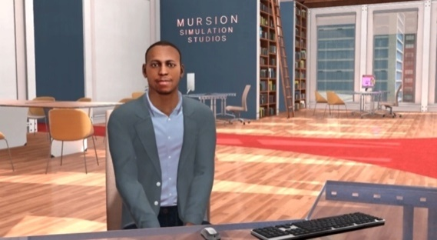
- If you plan to start in the middle of the scenario or want to assume any type of background information (i.e., we just finished our math lesson, will be starting the lesson right at the We Do part of the lesson, will assume the students just finished reading the passage provided with the lesson plan, etc.) let Michael know at this point.

Appendix A: Learner Participant Schedule

Sample Learner Participation Schedule: Recommendations for a 2-hr Lab Session

Less than 10 Participants in a Session
0 - 10 min | Participant A
12 - 22 min | Participant B
24 - 34 min | Participant C
36 - 46 min | Participant D
48 - 58 min | Participant E
58 - 1:10 min | Break/Debrief
1:12 - 1:22 min | Participant F
1:24 - 1:34 min | Participant G
1:36 - 1:46 min | Participant H
1:48 - 1:58 min | Participant I

10 - 18 Participants in a Session:
You can use the <10 schedule and assign co-participant to teach each lesson together (or engage in simulation).
0 - 10 min | Participant A & Participant J
12 - 22 min | Participant B & Participant K
24 - 34 min | Participant C & Participant L
36 - 46 min | Participant D & Participant M
48 - 58 min | Participant E & Participant N
58 - 1:10 min | Break/Debrief
1:12 - 1:22 min | Participant F & Participant O
1:24 - 1:34 min | Participant G & Participant P
1:36 - 1:46 min | Participant H & Participant Q
1:48 - 1:58 min | Participant I & Participant R

OR use the following alternating group schedule below so that each participant practices every other session and observes/provides peer feedback in between.

Sessions 1 & 3
0 - 10 min | Participant A
12 - 22 min | Participant B
24 - 34 min | Participant C
36 - 46 min | Participant D
48 - 58 min | Participant E
58 - 1:10 min | Break/Debrief
1:12 - 1:22 min | Participant F
1:24 - 1:34 min | Participant G
1:36 - 1:46 min | Participant H
1:48 - 1:58 min | Participant I

Sessions 2 & 4
0 - 10 min | Participant J
12 - 22 min | Participant K
24 - 34 min | Participant L
36 - 46 min | Participant M
48 - 58 min | Participant N
58 - 1:10 min | Break/Debrief
1:12 - 1:22 min | Participant O
1:24 - 1:34 min | Participant P
1:36 - 1:46 min | Participant Q
1:48 - 1:58 min | Participant R

19 - 36 Participant in a Session
You can use either the <10 schedule or the 10-18 alternating schedule and assign small groups of 2-4 to team-engage in each scenario together. If possible, try to ensure everyone engages in the simulator twice even if it is done in small groups.

37+ Participant in a Session
For larger groups please reach out if you would like additional support in designing a feasible schedule or would like to request additional hours. Please note we recommend keeping the number of participants in a session to 30 or less to maximize engagement and create a sense of community when possible.

Appendix B: Considerations for Practice
There are many strategies a facilitator can use when conducting a session. Selecting which strategy to use when creating a scenario depends on a variety of factors: scenario complexity, number of participants, and objective of scenario. There is no right or wrong answer! Below are just a few strategies to think about as you plan your scenario.
Individual Approach: Participants would enter the simulator on their own without an audience. The facilitator could be in the simulation watching or watch the recording later. This strategy is recommended for research studies or situations in which there are numerous participants. Timely feedback is highly recommended.

With a Partner/Co-teaching: This approach is helpful when participants are new to the simulation. Entering a simulation with a partner can boost confidence, allows for participants to co-plan together, and can help get numerous participants in and out of the simulator when dealing with large numbers.

Fishbowl Effect: Participants watch each other within the simulator. Participants who are actively engaged with the scenario are “inside” the fishbowl, while students who are watching the simulation take place are “outside” the fishbowl, listening and watching. Participants take turns in these roles, so that they all have an opportunity to engage in the scenario and provide feedback. This strategy is especially useful when you want to make sure everyone takes part in the simulation.

Appendix C: Feedback

Sample Feedback Document
Quality and timely feedback is an important part of the MRS experience. Below is a sample feedback document that can be used to help facilitate your simulation experience.
What went well? Name three specific examples with the corresponding timestamps.
What is an area to improve upon? List one specific example and explain why. Provide a suggestion for next steps to grow in this area.
What was your overall take-away from watching this video/live session? Identify something that stood out to you and will influence your practice.
Final comments/words of encouragement:

Appendix D: Avatar Bios

Early Childhood Elementary Students

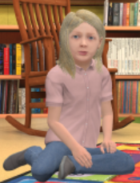
Luna Willis
Luna is very active and busy. She can be dramatic, silly and a bit mischievous. Luna likes loud, active spaces and struggles with quiet time. She may pout or tantrum if frustrated or overstimulated. Socially, Luna is a little bossy—still working on the mechanics of sharing and turn-taking. She is also compassionate; she gets worried when other kids get upset and matches what other kids are doing emotionally. She is younger in age (and developmentally) than the rest of the class and at times struggles with focus and attention.
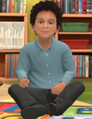
Andre Morales
Andre is practical and physical, he “likes to do stuff.” He’s a negotiator and can have a meltdown when he is mad or doesn’t get what he wants. In class, Andre is a visual learner and eager to share—especially about his things like construction, vacuuming, and dinosaurs. Socially, he loves talking about his Mom and Dad. He communicates his observations, and sometimes he may be distracted by the other students.
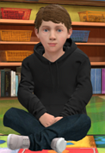
Mateo Hernandez
Serious and matter of fact, Mateo likes clear structure and expectations. He may not respond immediately to questions as he takes time to process. In class, Mateo prefers controlled environments. He likes investigating and experimenting with technology. Like Andre, Mateo likes building and playing with Legos. Socially, Mateo is shy at first. He thrives with independent work and play. Mateo prefers parallel play with most kids but enjoys cooperative play with his friend Archer.
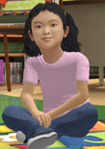
Anna Arita
Anna is matter-of-fact and demonstrates concrete thinking. She is confident, but without guile. She can be serious and a little secretive. In class, Anna loves to give details. When things feel out of alignment, she worries. Socially, anna is a little shy, but a good sharer. Once she opens up, she is playful and talkative. Anna loves make-believe and playing pretend. One of her favorite games is “jump on nothing,” a chasing game.
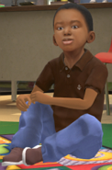
Brandon Nash
Brandon is a storyteller. He is curious, fearless, and at times may exaggerate. In class, Brandon picks things up quickly and may get distracted while other students are learning. He has a strong Imagination. Socially, Brandon is friendly and enthusiastic. You may see him talking and singing to himself, perhaps a song from his favorite movie, Moana.

Avatar Bios Cont.

Upper Childhood Elementary Students

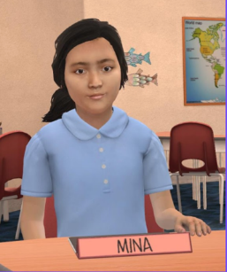
Mina Russell
Mina is socially the most “advanced” student in the class. She is very eager and engaged socially. She loves going to theatre camp over the summer and loves musical theatre. She’s a Student Ambassador for her school and takes great pride in the roles and responsibilities of the position. Mina is socially adaptable, lively, confident, and can find a way to make just about any situation a little more interesting.

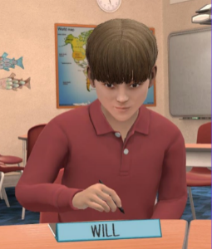
Will Ingraham
Will enjoys time alone and activities like skateboarding and playing video games. He likes plants, geology, and nature. He is relaxed and friendly with those he knows or shares similar interests. Will can be shy around new faces. He enjoys doing experiments and watching YouTube videos like the Try Guys or any experiment-type page and follows Robert Irwin on YouTube.

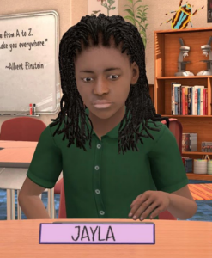
Jayla Reed
Jayla is fun, energetic, very bright and a deeply caring kid. She is a self-proclaimed nerd and carries herself with great confidence. She is caring and loves to tell jokes like her dad. She loves history, social studies, and any lessons about people and culture. Jayla is outgoing, socially active; introducing new content with friends will make her instantly comfortable. Jayla plays the tuba and loves to take dance classes. Jayla also loves theme parks.

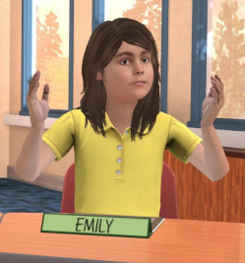
Emily Brinkerhoff
A shy dreamer, Emily tends to doodle. Introverted, studious, independent, serious, literal, does not need or seek attention. She strives in cooperative classroom vs competitive. She is not motivated by social acceptance. She loves drawing and coloring in artistic coloring books. Her hobbies also include: Music, art, writing and nature. Emily enjoys being an active part of her community, especially service-oriented tasks.

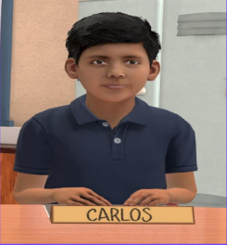
Carlos Cordova
Carlos has the mind of a future engineer. He is drawn to math and science. Carlos is an independent learner who does best in low teacher-student ratio classrooms. Carlos has meticulous attention to detail and can budget his time accordingly. He will set achievable goals and accomplish them. Carlos is reserved in the classroom but always willing to help. Carlos likes taking apart small electronics and putting them back together again.

Avatar Bios Cont.

Middle School Students

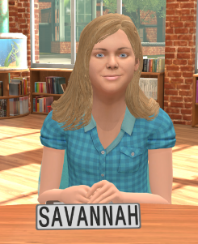
Savannah Boyd
Savannah has a strong mind for detail and has excellent analytical ability. She tends to work best on solo projects with clear directions in a quiet environment and may struggle with content if she doesn’t see practical applications. Personally, she tends to be introverted and may struggle to connect socially with her classmates, but she is loyal and kind. Her favorite subject is P.E. and she loves playing volleyball. Her ability for recall makes her a favorite team member at trivia night.

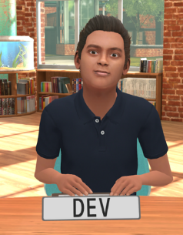
Dev Kapoor
Dev is self-driven and approaches learning with enthusiasm and an open mind. In the classroom, he prefers solo projects and may struggle with a loud environment. Personally, Dev is usually relaxed and friendly, but can at times be unknowingly insensitive to other’s feelings. His favorite subjects are band and math, and he loves playing music and discovering new artists.

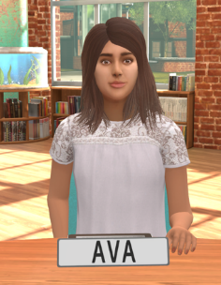
Ava Russo
Ava is quick-thinking and decisive and likes to be challenged with new ideas and concepts. She works well in a group and understands better when shown how to do something. Ava can be impatient with others when she feels the pace is too slow and can struggle in a more rule-based, structured environment. Personally, Ava is extroverted and loves taking the lead but can at times be too sarcastic or insensitive to others. Her favorite subject is history, and she loves anything related to dance.

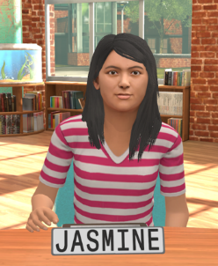
Jasmine Walker
Jasmine is an intuitive learner who likes to look at big ideas and patterns and understand relationships. She tends to engage in topics based on her interest or passion level. Small group work is generally successful for Jasmine, but she may struggle with criticism or conflict. Personally, Jasmine is an empathetic introvert, who prefers the familiar. Her favorite subjects are science and history, and she is passionate about animal rights.

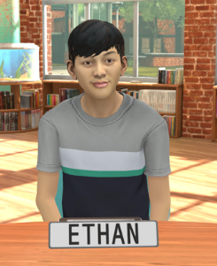
Ethan Mullen-Hardy
Ethan is an adventurous learner, willing to step out of his comfort zone and to understand new perspectives. He tends to respond best to short, direct instructions, with a mix of small group work and solo study and may struggle with detail-oriented work. Personally, Ethan is an extrovert, who loves to make others’ laugh and approaches most anything with a high level of energy. His favorite subject is language arts, and he loves playing soccer and video games in his spare time.

Avatar Bios Cont.

Middle School Students with Learning Disabilities

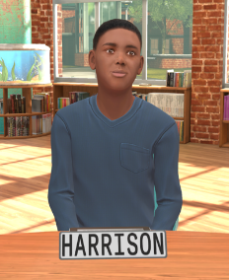
Harrison Reed
Harrison has above average intellectual ability with a specific learning disability which manifests in his auditory/verbal communication, including having difficulty processing complex language and multiple step directions. He is friendly and social if he feels his challenges aren’t a focal point and appreciates individualized attention and patience. His hobbies include video games, drawing and sports.

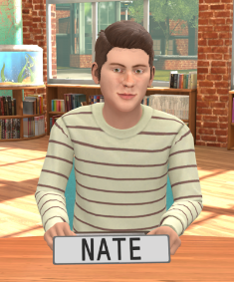
Nate Pittman
Nate has been diagnosed with high-functioning autism spectrum disorder. He is a strong visual learner and responds well to engaging via screens and technology. He struggles to understand figurative or abstract language, connecting socially and requires extra processing time for tasks. He responds well to concrete language, visual support strategies and repetition. His interests include science and math, the solar system and graphic design.

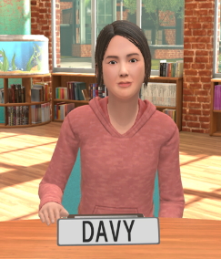
Davy Keo
Davy is from Cambodia and is currently a WIDA Level 3. She thrives with a combination of auditory and visual learning and is most comfortable working independently. She can struggle when language exceeds her grasp, or she doesn’t understand a cultural nuance. She appreciates a patient approach and the use of visual aids like flashcards, charts, graphic organizers, and puzzles. Her hobbies include music, volleyball, and art.

Avatar Bios Cont.

High School Students
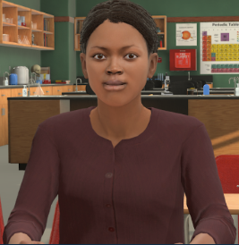
Ciara Dillon: She/her/hers
Ciara is extroverted and friendly. She is confident, but it is not forced confidence. Her family is in the military, and she lives in base housing, but goes to school off-base. In class, Ciara is a good writer and communicator. She is interested in science but doesn’t prefer math or things that “require memorization.” She is sociable and participates in many activities. At times, she can be overwhelmed and/or tightly wound trying to balance it all. Both of her parents are in the military, so she has moved many times.
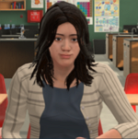
Angela Medina She/her/hers
Angela is quiet and analytical. She will dig into a topic that she is interested in, beyond what is required. In class, she questions and does not accept surface answers. She enjoys working through a challenge. She really likes STEM, particularly engineering and technology. She is comfortable with “think-pair-share" strategies but prefers working independently. Socially, Angela has a small but close-knit group of friends, including Jordan. Sha is vegan and volunteers for animal rights awareness events.

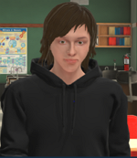
Jordan Burns: They/them/theirs
Jordan is quiet in class, but talkative with friends. Jordan loves to read and write (they may write and doodle in class when not engaged). In class, Jordan makes strong connections with material related to historical and/or literary context. Socially, Jordan is close with Angela, their friend, and their mother who has been very supportive of them coming out as non-binary. Jordan works part-time at a local coffee shop and while they do not like the work, the people there are open-minded and make the work fun.
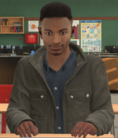
James Darby: He/him/his
James is extroverted, creative, and a natural leader. He plays bass in the HS Jazz ensemble and orchestra. In class, James enjoys group work and class presentations. He can get distracted by tangents and stories. His favorite subject is science. Socially, James is considerate. He will reach out to those who seem left out. While he has a close group of friends, he’s also a social butterfly. Everyone loves being around James—he is a contender for “Most Likely to Succeed” and “Friendliest” superlatives.

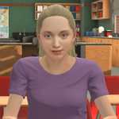
Stephanie Lawson: She/her/hers
Stephanie is driven to succeed. She embraces a challenge. She can be anxious. She is a people pleaser and wants everyone to get along (including the teacher). In class, Stephanie is eager to participate. She feels pressure to get into her mom’s alma mater. She is more focused on grades than what she wants to do. Socially, Stephanie is in the “popular” circle, but is a bit insecure and will follow rather than lead. She loves to participate in clubs like student council and the debate team. Stephanie loves
music and follows inspirational/body positivity influencers on social media.

Adults

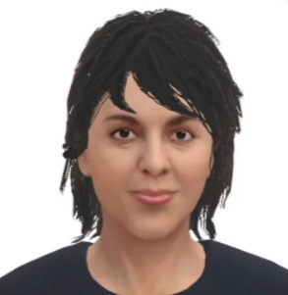
Linda Walker
Linda is 8th-grader Jasmine’s mother. Depending on context, she may participate as a parent, a teacher, a principal or other professional. Linda generally approaches situations with enthusiasm and a positive, talkative nature. She is not always great with details, can be impulsive and tends to value people over tasks but she tends to be a creative problem-solver and considers the feelings of others.

Max Mullen
Max is 8th-grader Ethan’s father. Depending on context, he may participate as a parent, a teacher, a principal or other professional. Generally, Max is confident and directive and tends to be very task-focused. He gets results and makes quick decisions but can lose sight of the people involved when rushed. Max tends to be straightforward and enjoys a challenge.

Donald Sera
Donald is an experienced teacher; he has been in his role for a number of years and is an influencer amongst his peers. He’s at his best when he is creating structure for himself and his class. His serious demeanor can be intimidating to the students (and parents) but he isn’t afraid to show his silly side when it’s appropriate. He lives with his wife and developmentally challenged adult son, Riley.

Serena Miranda
Serena is a first-year teacher. She has enthusiasm to spare! She approaches most things with a “can do” attitude. Her eagerness to “make it work” can often come at the expense of her own well-being. Her mom is a retired teacher in a different district. She lives with her parents and asks her mom for advice whenever she is faced with a challenge.

Teo Kimura
Teo has a few years of teaching under his belt. He fell into teaching when he had a hard time finding full time work as a musician. Although it wasn’t his first choice, he is still passionate about helping his students reach their potential. In his free time, he plays viola in a local amateur orchestra.

Angela Rodgers
Angela is a veteran teacher of 30 years. She loves teaching and can’t imagine retiring. She runs a tight ship and earns the respect of the students in her classroom very quickly. She is under more stress than usual because recently her husband had a stroke that pushed him into early retirement. She has two grown children: Adrien (son) and Denise (daughter).

Mitchell Ingraham
Mitchell is a single father and a man of few words. He does his best to support his son the best way he knows how: Encouraging him to be independent. He can get frustrated when helping Will with his homework because of the new math- “Why'd they have to go change math??”

Colleen Hart
Colleen is a very protective grandparent. She only sees the best in her grandchildren and is quick to defend them. She lost her husband years ago and is currently living with her son/daughter taking an active role in helping to raise the children.

Lisa Walker
Lisa is Jasmine’s mother. She is a very active parent within the school community, however, she doesn’t serve on the PTA. She is social and friendly. Despite her work taking up a lot of her time, she makes sure to drive Jasmine to all her extra curricular activities (Flag Team, Irish Dancing, etc). Her husband, Paul, also works at the ad agency. She has a step daughter, Amanda, who is in college.

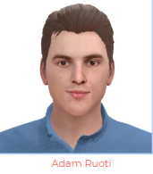
Adam Ruoti
Adam is Ethan’s dad. He has a tendency to become hyper focused on whatever is currently holding his attention. He has a high stress job but makes it a priority to spend quality time with his family. His partner, Tomás, owns and operates a Pet Boutique

Appendix E

How to Create a Zip file for a Mac

Here is an Instructional Video: https://youtu.be/euP3GCZn0sk
- Save all the files you want to zip in the same location, such as the same folder. Name the folder something that can be easily identified.
- Creating a zip file:
- Open the folder
- Select the files you want to zip
  - Command + A will select all files in the folder
  - If there are files you want to unselect, hold Command, use the mouse to click, and remove the selection
- Right-click one of the selected files
- Click Compress
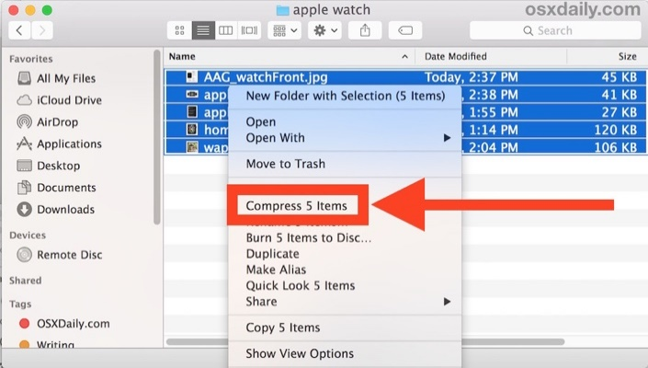

- Once a zip file is created, no additional files can be added to it. If more files are added to the original folder a new zip file can be created.

Upon completion, please send zip files to the MRS Lab jreese@educatordiversity.org

How to Create a Zip file for a PC

Instructional Video:
https://youtu.be/Ipn-T5Um3d4

- Save all the files you want to zip in the same location, such as the same folder. Name the folder something that can be easily identified.
- Creating a zip file:
- Open the folder
- Select the files you want to zip
  - Ctrl + A will select all files in the folder
  - If there are files you want to unselect, hold Ctrl, use the mouse to click, and remove the selection
- Right-click one of the selected files
- Point to send to
- Click compressed (zipped) folder
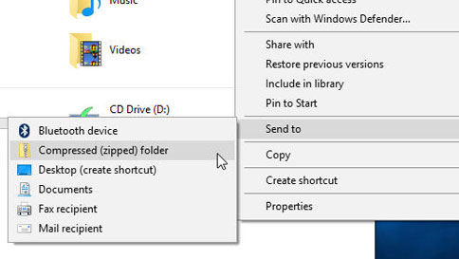

- Optional - Windows will automatically suggest a name for the zip file based on the original folder's name.
  - If you wish to rename the zip file:
    - Right-click the zip file
    - Click rename
    - Enter the new file name.
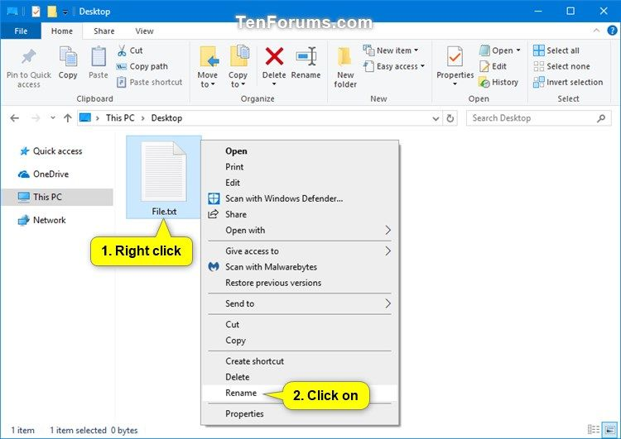

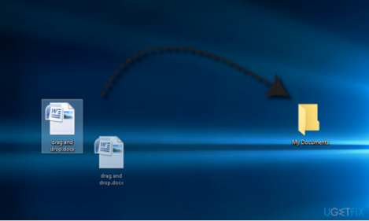

- After the zip file is created, you can add additional files by selecting the files you would like to add and dragging them to the top of the zip file.

Upon completion, please send zip files to the MRS Lab jreese@educatordiversity.org

Appendix F

Lesson Plan
This is a sample lesson plan template, no obligation to use it.
TEACHER NAME:
LESSON TITLE:
Standards of Learning:
Grade level, student audience

Objective
Lesson Assessment
Opening
I Do
We Do
You Do
Closing

Appendix G

Scenario Design Template Example I

Meet the Students | MRS LAB SIM  SCENARIO GUIDE

Outcome:  For the learner to facilitate an engaging activity to help get to know the students. They can use the heart map activity or expand.  Strategies/Best Practices to Consider  To hit this objective the learner will:  - Use engaging strategies to get to know students better  - Use person-first and asset-based language.  - Inquire about and affirm students ‘cultural, religious, family, intellectual, and personal experiences | Scenario Overview  Participant will facilitate dialogue about exploring the intersectionality in education & understand the important role that teacher education programs play in developing an understanding of sociocultural differences.  Ideal Simulation Configuration  - Environment: Elementary Ed  - Behavior Level: Low  - Avatars: Elementary  Learner Audience  - Preservice teacher  - Inservice teacher  - IHE faculty  - District leader  Supplemental Materials  - Teacher may create their own heart map to share with the students

Potential Perspectives:
Savannah | She tends to be introverted and may struggle to connect socially with her classmates.
 | shy and will only answer questions when asked- unless it has to do with volleyball, then she will interject and become engaged in the conversation.
Dev | Dev is enthusiastic and always willing to go first.
 | He is usually relaxed and friendly, but can at times be unknowingly insensitive to other’s feelings
Ava | Ava is extroverted and loves taking the lead but can at times be too sarcastic or insensitive to others.
 | She is quick-thinking and decisive, but can be impatient with others when she feels the pace is too slow and can struggle in a more rule-based, structured environment
Jasmin | Jasmine is an empathetic introvert, who prefers the familiar, and loves to have side conversations
 | She tends to engage in topics based but will start side conversations with Ava if she is not interested in the activity/lesson.
Ethan | Ethan is always willing to go first due to his adventurous personality.
 | Ethan is an extrovert, who loves to make others’ laugh and approaches most anything with a high level of energy.
Additional Information here | If the learner introduces themselves warmly and set clear expectations, the students will engage in the activity and follow the directions. If the learner acts nervous, rude in tone or does not set up expectation, students will disrupt and/or become off task

Appendix G

Scenario Design Template Example II

Leading Group Discussion: Equity & Dress Code | MRS LAB SIM  SCENARIO GUIDE

Outcome:  Your objective is to engage in an open conversation with your students about these policy updates. In your lesson you plan to engage your students regarding their perspective on these changes, but also take this opportunity to aid them in recognizing and supporting their awareness of everyday stereotypes, biases, and prejudices.  Strategies/Best Practices to Consider  To hit this objective the learner will:  - Create & set a framework for the discussion to includes everyone  - Use person-first and asset-based language.  - Inquire about and affirm students ‘cultural, religious, family, intellectual, and personal experiences | Scenario Overview  You are a Middle School teacher preparing to lead a discussion with your 8th Grade Class following their lunch period. For the past couple of weeks, you have been incorporating community-building activities to help build and create a positive and respectful classroom environment. Your school recently enacted new policies regarding grooming, hair and clothing standards and you plan to engage in an open conversation with your students about those policies. The students requested to discuss the new policies regarding the updated dress code policy regarding hair and clothing  Ideal Simulation Configuration  - Environment: Middle School  - Behavior Level: Medium  - Avatars: Middle  Learner Audience  - Preservice teacher  - Inservice teacher  - IHE faculty  - District leader  Supplemental Materials  - The Dress Code Policy

Potential Perspectives: During the simulation most of the students will be engaged in the discussion; however, there are reasons listed for each Avatar so that 1-2 can disengage over the course of the conversation. If a student is disengaged this is an opportunity for the Learner to engage them in the lesson. Student pushbacks come more from a place of questioning and those pushbacks are directed toward the teacher versus their fellow students
Savannah | Reasons may not be engaged in the discussion: Savannah doesn’t recognize that the policies impact her so she doesn’t see how she can contribute to the conversation
 | Perspective: It is what it is. Those are the rules, so we have to follow them. Nothing is going to change, so why keep talking about it? On game days Savannah wears her uniform (it goes against policy because she wears athletic shorts and her shirt is sleeveless, but because it is a uniform that is approved).
Dev | Reasons may not be engaged in the discussion: Dev is frustrated and feels like the students have no power because they’re “kids.” He doesn’t see the point in talking about it if nothing is going to happen.
Perspective: It seems like they’re telling us we should all look the same. That’s sad because we are all so different!
- They don’t know why someone is dressing the way they are… when they tell us we can wear wrinkled clothes or jeans with rips…what if that is all someone has to wear?
- What about the teachers? Do they have to follow the dress code? How is that fair for the students if the teachers don’t have to follow the dress code.”
Ava | Reasons may not be engaged in the discussion: Doesn’t trust the teacher, thinks they are part of the problem because they’re the ones enforcing the rules
Perspective: It’s a total double standard. Guys can wear whatever they want, and no one is checking the length of their shorts.
- [ TikTok: @drooscroo.] Wears the same clothes as his friends every day but the girls were written up and he wasn’t.
- What about Spirit week? We have crazy hair week which is already super offensive with the name, but also people wear wigs and hats that don’t even follow standards!
Jasmin | Reasons may not be engaged in the discussion: Recognizes that she is privileged by teachers making exceptions for her in the past and she is not comfortable having this conversation.  - It just doesn’t feel right for me to have an opinion because I have broken the rules before, and teachers haven’t said anything to me. Teachers are never worried about me breaking the rules
 | Perspective: Dress code is sexist because it blames us for how people look at us. ○ It says no sleeveless shirts for boys or girls, but I’ve only ever seen the girls get in trouble
Ethan | Reasons may not be engaged in the discussion: Everyone seems upset, and he is uncomfortable with the conflict.
 | Perspective: I actually think it’s a good idea. If we’re not worried about how everyone looks then people won’t get made fun of if they don’t have the best stuff
Additional Information here | If the learner introduces themselves warmly and set clear expectations, the students will engage in the activity and follow the directions. If the learner acts nervous, rude in tone or does not set up expectation, students will disrupt and/or become off task

Appendix H

Scenario Design Template

Scenario Name Here | MRS LAB SIM  SCENARIO GUIDE

Outcomes  Brief overview of what you would like to learner and avatars to experience during the scenario.  Strategies/Best Practices to consider:  Here you will write what you want the learner to do.  To hit this objective the learner will:  - Write objective here  - Write objective here  - Write objective here | Scenario Overview:  This is what would go on the Learner Facing Vignette.  Ideal Simulation Configuration  - Environment: Elementary Ed  - Behavior Level: Low  - Avatars: Elementary  Learner Audience  - Preservice teacher  - Inservice teacher  - IHE faculty  - District leader

Potential Perspectives: Provide content to help the Sim Specialist be able to create an environment that will elicit the behaviors you would like your learner to display. How will the avatar feel? How might they react?
Avatar’s Name
Avatar’s Name
Avatar’s Name
Avatar’s Name
Avatar’s Name
Additional Information here

